During our children’s time at home they will be using technology more to access remote learning. Some of them will also be using social media to stay in touch with their friends. It is important that they stay safe online. Below are some useful links to support parents and carers in this area.
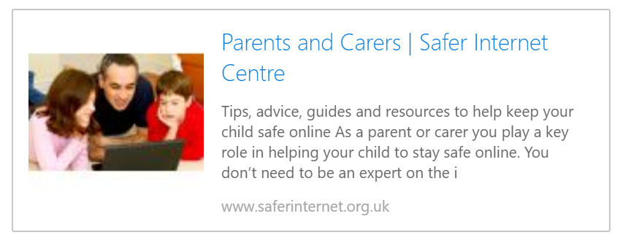
https://www.saferinternet.org.uk/advice-centre/parents-and-carers

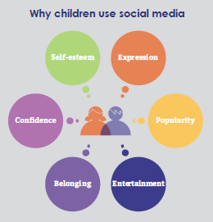

Social media guidance

